Model of Distribution of Budget Vacancies in University

DSc. Olena Rayevnyeva,
Professor, chief of statistical and economical forecasting department, Kharkiv National Economical University
Kharkiv, Ukraine
Olena_rayev@mail.ru

DSc. Kostyantyn Stryzhychenko
Professor of statistical and economical forecasting department, Kharkiv National Economical University
Kharkiv, Ukraine
strizh@bk.ru

Dr. Stanislav Milevsky
Associated professor of statistical and economical forecasting department, Kharkiv National Economical University, Kharkiv, Ukraine

___________________________________________________________________
ABSTRACT— In the current work we analyze the demand and stability of the development of Ukrainian educational market. In the article we propose the methodology of the investigation of higher educational market which includes three main units. We determine the structure of demand for specialists with higher education for certain types of economic activity. Also, investigation of the disproportions between supply and demand of specialists with higher education by the economic activity areas. In the article, we analyzed the stable and unstable periods of the educational market development and cointegration educational market with the labor market. The stability theory and non-linear analysis are the mathematical tools of the investigation.

Keywords— higher education, stability, demand, educational market, forecasting.
___________________________________________________________________

1. INTRODUCTION
The processes of higher education autonomization, which started in the 20th century in Europe, greatly influenced the development of the institutional autonomy of higher educational establishments worldwide. Universities autonomy allows the use of both existing and new features to enhance the university position.
Broadly speaking, the provision of university autonomy means granting it independence and responsibility in decision making. [1] In Magna Charta Universitatum universities autonomy is defined the next way: “The university is an autonomous institution at the heart of societies differently organized because of geography and historical heritage; it produces, examines, appraises and hands down culture by research and teaching”. [2]
The evolution of university autonomy can be seen as follows [1, 3]:
1) 1158 – the first adopted decree "On university autonomy» (Authentica habita, University of Bologna) by Emperor Frederick Barbarossa who sacked the students and teachers of duties and taxes;
2) 1231 – a formal appeal of the Pope - the Papal Bull (Parens Scientiarum, Paris), which recognized the right of universities as a legal entity to assign degrees;
3) the beginning of the XIX century – the idea of Wilhelm von Humboldt (Humboldt education reform) on the structure of the university, which was expressed in the form of freedom in teaching, learning, unity in education and research and formed the basis for a modern research university and the modern concept of academic freedom;
4) XIX century - Regulatory policy regarding universities of Western Europe (reducing the role of the autonomy of universities - increasing state control);
5) 1965 - International Association of Universities (IAU) defined university autonomy as an authority in decisions on: who will teach, what will be taught, who will learn, who gets a degree, and what should be researched;
6) 1970 - Organization for Economic Co-operation and Development (OECD) conducted the first study on the "index of autonomy" in decision-making structure among 52 higher education institutions in Europe.
Key stages in the lately development of the institutional autonomy of universities and their main provisions are summarized in Table 1.
The possibility of implementing the institutional autonomy main principles laid down in the Law of Ukraine "On Higher Education" [12].
In The Law university autonomy is defined as autonomy, independence and accountability of higher education in making decisions regarding the development of academic freedom, organization of educational process, research, internal governance, economic and other activities, independent selection and placement of personnel within the limits established by this Law.
Successful implementing of main principles of institutional autonomy will allow Ukraine’s universities to maintain development in conditions of economic, social and demographic crisis.
The main challenges for the Ukrainian universities in this context are:
The difficult economic situation;
Negative changes in the demographic situation;
Increased competition in the market of educational services.
The deepening of economic crisis leads to a significant reduction in the population's solvency. In fact, most of the students are not able to pay for studying on a contract basis to university. Data illustrating stated problems are shown in Table. 2.
Table 1. Key stages in the development of the modern university institutional autonomy
Event | Achievements
Magna Charta Universitatum  (1988) [2] | 1. The university is an autonomous institution within societies with different organization resulting from differences in geography and historical heritage. It produces, examines, appraises and hands down culture by research and teaching. To meet the needs of the world, its research and teaching must be morally and intellectually independent of all political and economic power.  2. Teaching and research in universities must be inseparable in order to study process met the needs of the changing society, and advances in scientific knowledge.  3. Freedom in research and training is the fundamental principle of university life. And governments and universities, each within its competence, must ensure respect for this fundamental requirement.
The Lima Declaration on Academic Freedom and Autonomy of Institutions of Higher Education (1988) [4] | 'Autonomy' means the independence of institutions of higher education from the State and all other forces of society, to make decisions regarding its internal government, finance, administration, and to establish its policies of education, research, extension work and other related activities.  Academic freedom is an essential pre-condition for those education, research, administrative and service functions with which universities and other institutions of higher education are entrusted.  States are under an obligation to respect and to ensure to all members of the academic community, those civil, political, economic, social and cultural rights recognised in the United Nations Covenants on Human Rights.  All members of the academic community with research functions have the right to carry out research work without any interference, subject to the universal principles and methods of scientific enquiry.  All members of the academic community with teaching functions have the right to teach without any interference, subject to the accepted principles, standards and methods of teaching.  All members of the academic community shall enjoy the freedom to maintain contact with their counterparts in any part of the world as well as the freedom to pursue the development of their educational capacities.  All students of higher education shall enjoy freedom of study, including the right to choose the field of study from available courses and the right to receive official recognition of the knowledge and experience acquired.  All members of the academic community have the right to freedom of association with others, including the right to form and join trade unions for the protection of their interests.  The proper enjoyment of academic freedom and the compliance with the responsibilities mentioned in the foregoing articles demand a high degree of autonomy of institutions of higher education.  The autonomy of institutions of higher education shall be exercised by democratic means of self-government, which includes the active participation of all members of the respective academic communities. All members of the academic community shall have the right and opportunity, without discrimination of any kind, to take part in the conduct of academic and administrative affairs. All governing bodies of institutions of higher education shall be freely elected and shall comprise members of the different sectors of the academic community. The autonomy should encompass decisions regarding administration and determination of policies of education, research, extension work, allocation of resources and other related activities.
Sorbonne Joint Declaration (1988) [5] | A convention, recognizing higher education qualifications in the academic field within Europe, was agreed on last year in Lisbon. The convention set a number of basic requirements and acknowledged that individual countries could engage in an even more constructive scheme. Standing by these conclusions, one can build on them and go further. There is already much common ground for the mutual recognition of higher education degrees for professional purposes through the respective directives of the European Union. Our governments, nevertheless, continue to have a significant role to play to these ends, by encouraging ways in which acquired knowledge can be validated and respective degrees can be better recognized. We expect this to promote further inter-university agreements. Progressive harmonization of the overall framework of our degrees and cycles can be achieved through strengthening of already existing experience, joint diplomas, pilot initiatives, and dialogue with all concerned.
The Bologna Declaration of 19 June 1999 [6] | European higher education institutions, for their part, have accepted the challenge and taken up a main role in constructing the European area of higher education, also in the wake of the fundamental principles laid down in the Bologna Magna Charta Universitatum of 1988. This is of the highest importance, given that Universities' independence and autonomy ensure that higher education and research systems continuously adapt to changing needs, society's demands and advances in scientific knowledge.
Salamanca Declaration (2001) [7] | Principles:  Institutional autonomy with accountability.  Education clearly viewed as a public responsibility.  Enhancement of research-based higher education.  Respect for diversity.  Key Issues:  Quality as a fundamental building block.  Trust building.  Relevance of the curriculum to real-world needs.  Mobility of students, graduates, and professionals as a central value.  Compatibility and flexibility in the framework for qualifications at undergraduate and graduate levels.  Enhanced attractiveness of the European Higher Education Area for the rest of the world.
“Realising the European Higher Education Area” Communiqué of the Conference of Ministers responsible for Higher Education in Berlin on 19 September 2003 [8] | The quality of higher education has proven to be at the heart of the setting up of a European Higher Education Area. Ministers commit themselves to supporting further development of quality assurance at institutional, national and European level. They stress the need to develop mutually shared criteria and methodologies on quality assurance. They also stress that consistent with the principle of institutional autonomy, the primary responsibility for quality assurance in higher education lies with each institution itself and this provides the basis for real accountability of the academic system within the national quality framework.
London Communiqué 18 May 2007 [9] | Developments over the last two years have brought us a significant step closer to the realization of the European Higher Education Area (EHEA). Building on our rich and diverse European cultural heritage, we are developing an EHEA based on institutional autonomy, academic freedom, equal opportunities and democratic principles that will facilitate mobility, increase employability and strengthen Europe’s attractiveness and competitiveness.  We therefore underline the importance of strong institutions, which are diverse, adequately funded, autonomous and accountable. The principles of nondiscrimination and equitable access should be respected and promoted throughout the EHEA. We commit to upholding these principles and to ensuring that neither students nor staff suffer discrimination of any kind.
Communiqué of the Conference of European Ministers Responsible for Higher Education, Leuven and Louvain-la-Neuve, 28-29 April 2009 [10] | The necessary ongoing reform of higher education systems and policies will continue to be firmly embedded in the European values of institutional autonomy, academic freedom and social equity and will require full participation of students and staff.  Higher education institutions have gained greater autonomy along with rapidly growing expectations to be responsive to societal needs and to be accountable. Within a framework of public responsibility we confirm that public funding remains the main priority to guarantee equitable access and further sustainable development of autonomous higher education institutions. Greater attention should be paid to seeking new and diversified funding sources and methods.
Budapest-Vienna Declaration on the European Higher Education Area March 12, 2010 [11] | We, the Ministers, recommit to academic freedom as well as autonomy and accountability of higher education institutions as principles of the European Higher Education Area and underline the role the higher education institutions play in fostering peaceful democratic societies and strengthening social cohesion.

Table 2. Data illustrating negative tendencies in Ukraine*
Indicator | 2010 | 2011 | 2012 | 2013 | 2014 | 2015
Average income for one family, UAH | 3481 | 3853,9 | 4144,5 | 4470,5 | 4563,3 | 5231,7
Inflation index | 109,1 | 104,6 | 99,8 | 100,5 | 124,9 | 143,3
Exchange rate UAH/USD | 7,93 | 7,96 | 7,99 | 7,99 | 11,88 | 21,84
Average monthly income for one family, USD | 438,97 | 484,16 | 518,71 | 559,51 | 384,12 | 239,55
Amount of school graduates, thousands | 391 | 364 | 215 | 329 | 304 | 247
Students accepted for training, thousands | 392 | 314,5 | 341,3 | 348 | 291,6 | 259,9
Students who pay tution fees, thousands | 447 | 492 | 527 | 568 | 396 | 261
*sources: State Statistic Service of Ukraine official site http://www.ukrstat.gov.ua/ [13], National Bank of Ukraine official site https://bank.gov.ua/ [14]
Fig. 1 shows the dynamics of changes in household incomes in Ukraine.

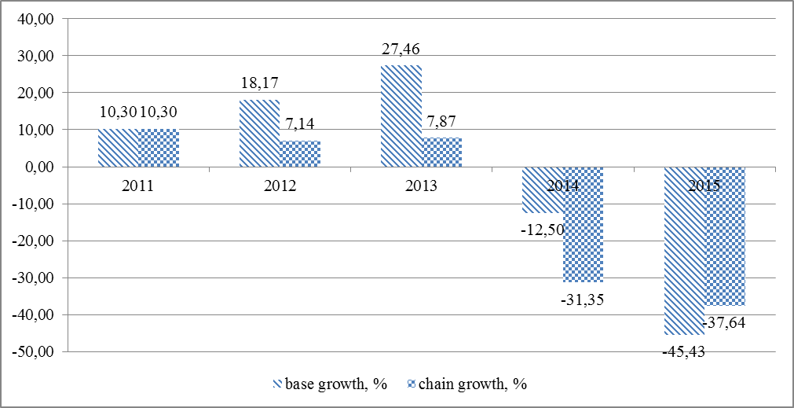

Figure 1. Dynamics of average monthly income for one family, USD (%)

The diagram illustrates the positive trend of income up to 2013 inclusive. Subsequent trend shows a substantial decrease in household incomes in both the chain and in basic terms.
A significant decline in real incomes and the increase in the negative effects of inflation reduces the ability of prospective students to pay tuition contract whose value is an average of 300 to 800 USD per year. These trends have led to increased tendency of sharp drop in number of students enrolled in the contract form of studying. This trend is approximated by a polynomial function of 2-nd degree (R² = 0,92). Several smoother results obtained by predicting on average growth rates. The expected value of the amount of contract students will be: in 2016 – 234 thousand, and in 2017 – 210 thousand (Fig. 2).

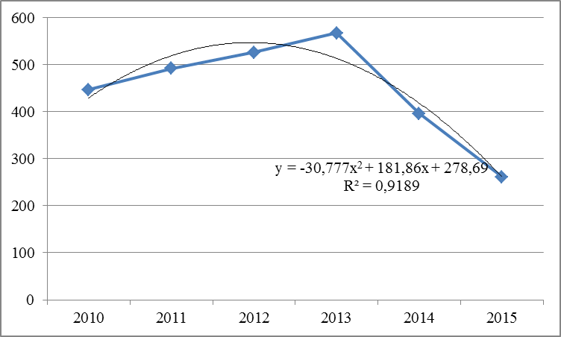

Figure 2. Trend in decreasing amount of “commercial” students in Ukraine (thousands)
Simultaneously with the reduction of solvent demand for university services, increased competition between institutions of higher education caused by demographic processes. There is a wave-like change in the number of school leavers with a clear downward trend. Accordingly, it reduces the number of potential applicants and students accepted for training (Fig. 3).
This situation significantly affects the development of higher education in Ukraine. Thus, the universities need to make maximum use of all opportunities to preserve autonomy and strengthen their positions. One of the ways is to strengthen the financial autonomy of universities independence. Implementation of this direction allows to intensify the process of resources attraction. Among the higher education funding sources share of the tuition fees takes a considerable position. Implementation of higher educational establishments autonomy in the area of internal control is possible by redistribution of “budget” places between the university specialties. The solving of this optimization problem will both increase the economic efficiency and financial autonomy of the university, and will help to strengthen the image-attractiveness of the higher educational establishments.

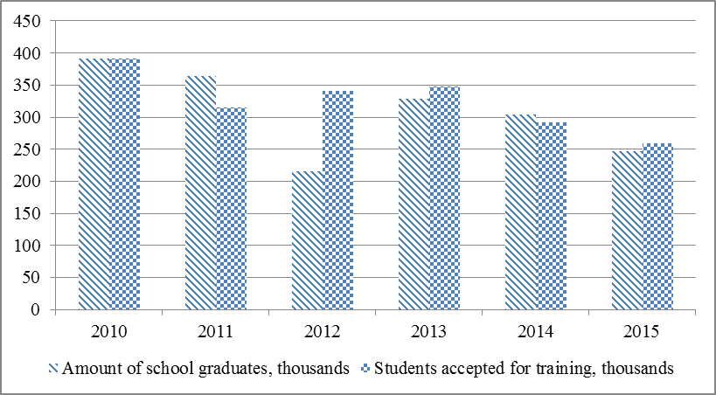

Figure 3. Decreasing trend of students, accepted for learning in higher education institutions

Total funding of higher educational establishments in Ukraine consists of two main components: funding from the state budget - according to the number of a "budget" places assigned to a specific higher educational establishment, and funding from individuals and legal entities - the so-called "contractual" places. In the conditions of adopted in 2016 "budget" places allocation system, higher educational establishments has no control over their redistribution between specialties within the university. This greatly reduces the possibility of effective management of higher educational establishments activities and violate the principles of autonomy. In addition, the adopted rules imply that the amount of "budget" places allocated in the next academic year cannot be more than in the previous. Thus, with the natural fluctuations of the number of students between the regions and universities there is a risk of a stable change of the regional distribution of public funding of higher educational establishments. To minimize these negative effects it seems to be appropriate to provide autonomy of higher educational establishments in the field of redistribution of "budget" places between specialties (or specializations). This will also increase the overall attractiveness of the university for students and its economic efficiency through the implementation of the principles of autonomy. To solve this problem optimization economic and mathematical model was developed. It optimizes the distribution of "budget" vacancies between specialties (or specializations) within the university. We propose to solve following task for this aim:
i) Determination of the demand for specialists with higher education in specializations;
ii) Construction the model of the distribution of budget vacancies;
iii) Analysis the optimize and real value of the of the distribution of budget vacancies in University;
We constructed methodology to solve these tasks.
2. METHODOLOGY
2.1. Objective function
The main purpose of distribution of budget vacancies in universities could be described from two sides. From the external side, effective distribution of budget vacancies increases the image level of university in the competitive environment. From the internal side, we can increase the profitability of university through distribution of budget vacancies. In this case, we need determine the utility of one budget vacancy for the university.
The unbudgeted vacancies receive great importance for the profitability of university in the conditions of increase of university’s autonomy. Therefore, university can use the distribution of budget vacancies for the management of unbudgeted distribution because big correlation exists between unbudgeted and budget vacancies.
The objective function of model of distribution of budget vacancies is maximize of attractiveness of one budget vacancy, that calculated by the formula:

(1)
Where is attractiveness of one budget vacancy for i specialization; is retrospective quantity of unbudgeted vacancies by i specialization in university; is retrospective quantity of budget vacancies for i specialization.

The objective function is

(2)
Where m is quantity of specialization in university; is the share of quantity of budget vacancies for i specialization.
2.2. Linear constraints.
- The limit of budget vacancies
(3)

- Volatility condition for specialization
Volatility shows the changes of budget vacancies and contains two coefficients. There are attractiveness coefficient of specialization of the national economy (k) and variance coefficient of utility of specialization in university (v).
The attractiveness coefficient calculated by the formula
(4)

The variance coefficient of attractiveness of specialization calculated by the formula
(5)
Therefore, the total volatility condition is

(6)
Where is forecast of the share of budget vacancies by i specialization in t+1 period; and is minimum and maximum levels of the interval forecast of the share of budget vacancies.

Thus, the model of the distribution of budget vacancies is
(7)

3. RESULTS

3.1. Determining of the parameters of objective function
According the fig. 3 on the step 1.1 we forecasted the demand of higher educational specialists demand by the specialization. These date show in the table 3.
Table 3. The demand for specialist with higher education for national economy
Specialization | Interval forecasts |  | Share of the budget vacancies |  | Forecast 2017
 | minimum | maximum | minimum | maximum
Labor economics | 1524 | 1684 | 0,085 | 0,085 | 1604
Enterprise economics | 1747 | 1931 | 0,097 | 0,097 | 1839
Accounting and taxation | 3267 | 3611 | 0,181 | 0,181 | 3439
Economic theory | 348 | 384 | 0,019 | 0,019 | 366
Finance, banking and insurance | 5946 | 6572 | 0,330 | 0,330 | 6259
International Economics | 671 | 741 | 0,037 | 0,037 | 706
Marketing | 2447 | 2705 | 0,136 | 0,136 | 2576
Applied Statistics | 1052 | 1162 | 0,058 | 0,058 | 1107
Economical Cybernetics | 1027 | 1135 | 0,057 | 0,057 | 1081

This table shows that exist high level of share for the following specialization: finance, banking and insurance (0,330) and accounting and taxation (0,181). The analyses of the direction of the national economy development give us following date concern attractiveness volatility coefficient (table 4). Also, we calculated the variance volatility coefficient in this table.
Table 4. The volatility coefficients
Specialization | Average value of attractiveness of one budget vacancy () | Variance coefficient () | Attractiveness volatility coefficient ()
Labor economics | 1,38 | 0,52 | 0,964
Enterprise economics | 1,16 | 0,51 | 0,951
Accounting and taxation | 1,17 | 0,36 | 0,923
Economic theory | 0,31 | 0,07 | 0,844
Finance, banking and insurance | 0,74 | 0,25 | 0,939
International Economics | 1,03 | 0,36 | 0,95
Marketing | 1,08 | 0,36 | 1,011
Applied Statistics | 0,47 | 0,27 | 0,965
Economical Cybernetics | 0,77 | 0,22 | 0,952

Thus, the calculation of the date of linear constraints is in the table 5.
Table 5. Linear constraints of model
Specialization | Limits of the linear constraints
Labor economics | 0,0375 | 0,1254
Enterprise economics | 0,0427 | 0,1416
Accounting and taxation | 0,1020 | 0,2325
Economic theory | 0,0149 | 0,0176
Finance, banking and insurance | 0,2272 | 0,3922
International Economics | 0,0219 | 0,0487
Marketing | 0,0884 | 0,1861
Trade management | 0,0405 | 0,0720
Applied Statistics | 0,0417 | 0,0668
Economical Cybernetics | 0,0375 | 0,1254

3.2 Distribution of budget vacancies in Simon Kuznets Kharkiv National University of Economics
We calculated base the date from table 4 and table 5. The results of the calculations are in the table 6
Table 6. The results of the optimization of distribution of budget vacancies in universities
Specialization | Optimized absolute value of utility of one budget vacancy |  | Real absolute value of utility of one budget vacancy in 2013 |  | Budget vacancies 2013
 | objective function | The share of budget vacancy | objective function | The share of budget vacancy | Real | Optmized
Labor economics | 0,173 | 0,125 | 0,093 | 0,068 | 20 | 37
Enterprise economics | 0,164 | 0,142 | 0,157 | 0,135 | 40 | 42
Accounting and taxation | 0,272 | 0,233 | 0,178 | 0,152 | 45 | 69
Economic theory | 0,005 | 0,015 | 0,008 | 0,027 | 8 | 4
Finance, banking and insurance | 0,168 | 0,227 | 0,245 | 0,331 | 98 | 67
International Economics | 0,023 | 0,022 | 0,122 | 0,118 | 35 | 6
Marketing | 0,166 | 0,154 | 0,080 | 0,074 | 22 | 46
Applied Statistics | 0,019 | 0,041 | 0,024 | 0,051 | 15 | 12
Economical Cybernetics | 0,032 | 0,042 | 0,034 | 0,044 | 13 | 12
TOTAL | 1,022 | 1,000 | 0,941 | 1,000 | 296 | 296
Efficienty |  |  | 0,92
We have following results of the analysis of the distribution of the budget vacancies:
i) Big disproportion exists between optimize and real budget vacancies for the international economics specialization (483%), economic theory specialization (100%) and finance, banking and insurance specialization (46%).
ii) In that time, some specializations need more budget vacancies. There are marketing (52% increase), labor economics (46%) and accounting and taxation (35%).
iii) The efficiency of real distribution of budget vacancies is 0,92 (92%). It shows two sides of distribution. From one side, the attractiveness for all specialization is close for each other. From other side, University made efficiency distribution without model of distribution.

5. CONCLUSION
Thus, we have following main results in this article:
1) We constructed the model of distribution of budget vacancies, which maximize the University attractiveness through maximize of budget vacancies for the specialization. The attractiveness of the specialization is share of unbudgeted vacancy in budget vacancy for each specialization. Therefore, University can increase the profitability through increase unbudgeted vacancy.
2) The objective function for real and optimize value of the distribution is too close. But variation of the disproportions between real and optimize value is 285%. It shows low level of orientation onto the demand of the national economy. In this situation, University needs to find a balance between their interests and the interests of the national economy. This balance can be based onto the profitability of one budget and one unbudgeted vacancies in University.
Therefore, followed by the development model is modification of models in different profitability of budget and unbudgeted vacancies in University.
References
1. М. Михайліченко, Л. Макодзей. Університетська автономія: історичні реалії та виклики сьогодення http://www.edu-trends.info/wp-content/uploads/2015/04/Makodzei-Mykhailichenko_abstract_16_04_15.pdf?c6a0f6
2. Magna Charta Universitatum http://www.magna-charta.org/resources/files/the-magna-charta/english
3. Раєвнєва О. Іміджева привабливість вищих навчальних закладів як фактор нецінової конкуренції на ринку освітніх послуг / О. Раєвнєва// Вища школа. - 2015. - № 9/10. - С. 109-126
4. The Lima Declaration on Academic Freedom and Autonomy of Institutions of Higher Education (1988) https://www.hrw.org/legacy/reports98/indonesia2/Borneote-13.htm
5. Sorbonne Joint Declaration 1988 http://media.ehea.info/file/1998_Sorbonne/61/2/1998_Sorbonne_Declaration_English_552612.pdf
6. The Bologna Declaration of 19 June 1999 http://www.eurashe.eu/library/modernising-phe/Bologna_1999_Bologna-Declaration.pdf
7. Salamanca Declaration 2001 http://accreditation.org/accords/salamanca-declaration-2001
8. “Realising the European Higher Education Area” Communiqué of the Conference of Ministers responsible for Higher Education in Berlin on 19 September 2003 http://www.ond.vlaanderen.be/hogeronderwijs/bologna/documents/MDC/Berlin_Communique1.pdf
9. London Communiqué 18 May 2007 http://webarchive.nationalarchives.gov.uk/20100202100434/http://dcsf.gov.uk/londonbologna/uploads/documents/londoncommuniquefinalwithlondonlogo.pdf
10. Communiqué of the Conference of European Ministers Responsible for Higher Education, Leuven and Louvain-la-Neuve, 28-29 April 2009 http://www.ond.vlaanderen.be/hogeronderwijs/bologna/conference/documents/Leuven_Louvain-la-Neuve_Communiqu%C3%A9_April_2009.pdf
11. Budapest-Vienna Declaration on the European Higher Education Area March 12, 2010 http://www.ond.vlaanderen.be/hogeronderwijs/bologna/2010_conference/documents/Budapest-Vienna_Declaration.pdf
12. Закон України «Про вищу освіту» http://zakon2.rada.gov.ua/laws/show/ru/1556-18
13. State Statistic Service of Ukraine official site http://www.ukrstat.gov.ua/
14. National Bank of Ukraine official site https://bank.gov.ua/

